Hong Kong Exchanges and Clearing Limited and The Stock Exchange of Hong Kong Limited make no responsibility for the contents of this announcement, make no representation as to its accuracy or completeness and expressly disclaim any liability whatsoever for any loss howsoever arising from or in reliance upon the whole or any part of the contents of this announcement.

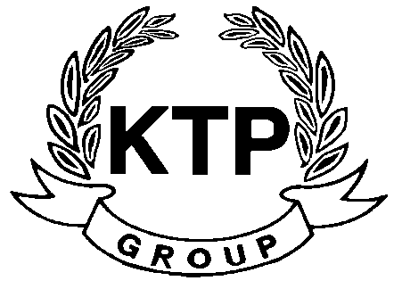
KTP HOLDINGS LIMITED
(Incorporated in Bermuda with limited liability)
(Stock code: 645)

ANNOUNCEMENT

At the request of KTP Holdings Limited (the “Company”), trading in the shares of the Company will remain suspended pending the release of an announcement to clarify certain information contained in an announcement published by the Company on 5th August 2010.

As at the date of this announcement, the Board is comprised of 5 Directors, of which Mr. LEE Chi Keung, Russell and Miss. YU Mee See, Maria are executive Directors, Mr. NG Wai Hung, LEE Siu Leung and Mr. YUEN Sik Ming are independent non-executive Directors.

By Order of the Board
KTP Holdings Limited
Lee Chi Keung, Russell
Chairman

Hong Kong, 6th August 2010

